Ortak Anot

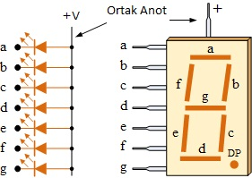

Ortak Katot

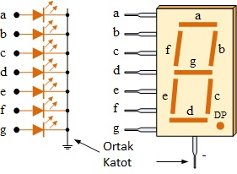

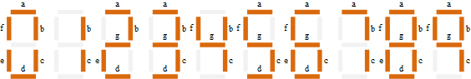

|  |  |  |  |  |  |  |  |  |
| --- | --- | --- | --- | --- | --- | --- | --- | --- |
| Ortak Anot | P2.7 | P2.6 | P2.5 | P2.4 | P2.3 | P2.2 | P2.1 | P2.0 |
| Hangi Şekil | a | b | c | d | e | f | g | h(DP) |
| 4(99H) | 1 | 0 | 0 | 1 | 1 | 0 | 0 | 1 |
| 5(49H) | 0 | 1 | 0 | 0 | 1 | 0 | 0 | 1 |
| 7(1Fh) | 0 | 0 | 0 | 1 | 1 | 1 | 1 | 1 |

|  |  |  |  |  |  |  |  |  |
| --- | --- | --- | --- | --- | --- | --- | --- | --- |
| Ortak Katot | P2.7 | P2.6 | P2.5 | P2.4 | P2.3 | P2.2 | P2.1 | P2.0 |
| Hangi Şekil | a | b | c | d | e | f | g | h(DP) |
| 4(66h) | 0 | 1 | 1 | 0 | 0 | 1 | 1 | 0 |
| 5(0B6H) | 1 | 0 | 1 | 1 | 0 | 1 | 1 | 0 |
| 8(0FEH) |  |  |  |  |  |  |  |  |



4x4 keypad

|  |  |  |  |  |  |  |  |
| --- | --- | --- | --- | --- | --- | --- | --- |
|  |  | C1 | C2 | C3 | C4 |  |  |
|  |  | 0.3 | 0.2 | 0.1 | 0.0 |  |
| R1 | 0.7 |  |  |  |  |  |
| R2 | 0.6 |  |  |  |  |  |
| R3 | 0.5 |  |  |  |  |  |
| R4 | 0.4 |  |  |  |  |  |